# Supplemental material for

Integrating mass cytometry and transcriptomics into a comprehensive profile of chikungunya infection

## Authors

Daniela Michlmayr,\* Theodore R. Pak,\* Adeeb Rahman, El-Ad David Amir, Eun-Young Kim, Steven Wolinsky, Andrew Kasarskis, and Eva Harris

**Manuscript word count:**

\* These authors contributed equally to this work.

# Corresponding author:

# Supplementary Figures

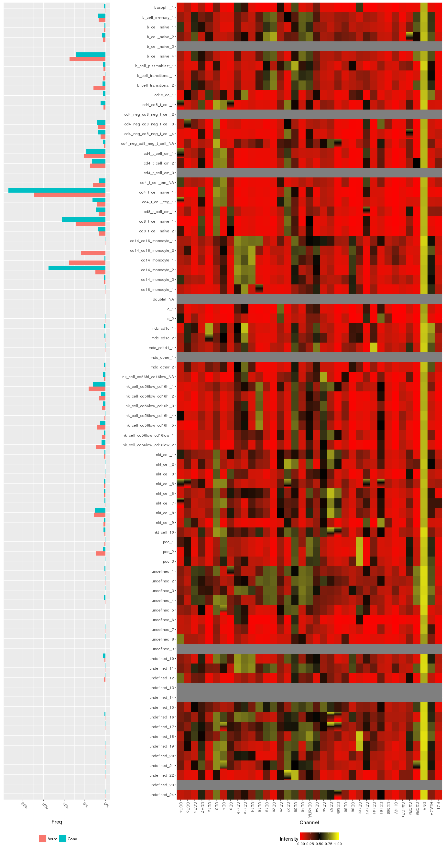

*continued on next page*



**Figure S1**. Example output of MetaHybridLouvain for the representative sample used in Figure 2A, Figure 3B, and 3D. At left, frequencies for each sub-community at each timepoint, and at right, mini-heatmaps of channel values for each sub-community (plotted within each row). As expected, sub-communities generally show similar values among all channels for their constituent events, with some exceptions (vertical gradients within mini-heatmaps).

Macintosh HD:Users:powerpak:Dropbox:MSSM:kasarskis:dengue grant:chik paper:figs:fig_S2_corr_IgG_cd14cd16_mono_1.pdf

**Figure S2**. Correlations between acute phase cell sub-community frequencies and log10 CHIKV IgG titer at 15d post-symptom onset. *A*, Q-Q plot of the distribution of observed –log10 *P* values against the distribution of –log10 *P* values expected under the null hypothesis (that Spearman’s *ρ* = 0 for all populations). Gray shaded band indicates the 95% confidence interval for the expected *P* value distribution under the null hypothesis. *B*, Scatterplots of log10 cell sub-community frequencies against log10 IgG CHIKV titer at the 15d timepoint for the three sub-communities whose *P* values are labeled in A. Of these, only the CD14+CD16+ monocyte 1 correlation is significant after multiple hypothesis correction (BF *P* = 0.0097, Spearman’s *ρ* = 0.60).

Macintosh HD:Users:powerpak:Dropbox:MSSM:kasarskis:dengue grant:chik paper:figs:fig_S3_cd14c16_monocytes_subpop_differences.pdf

**Figure S3.** Differences in per-sample channel means between two CD14+CD16+ sub-communities identified by MetaHybridLouvain. 1 corresponds with the “intermediate” CD14++CD16+ phenotype, while 2 corresponds with the “nonclassical” CD14+CD16++ phenotype. The X axis is filtered to only the channels with differences significant at FDR < 0.05, and ordered from differences where sub-community 1 < 2 on the left to sub-community 1 > 2 on the right.

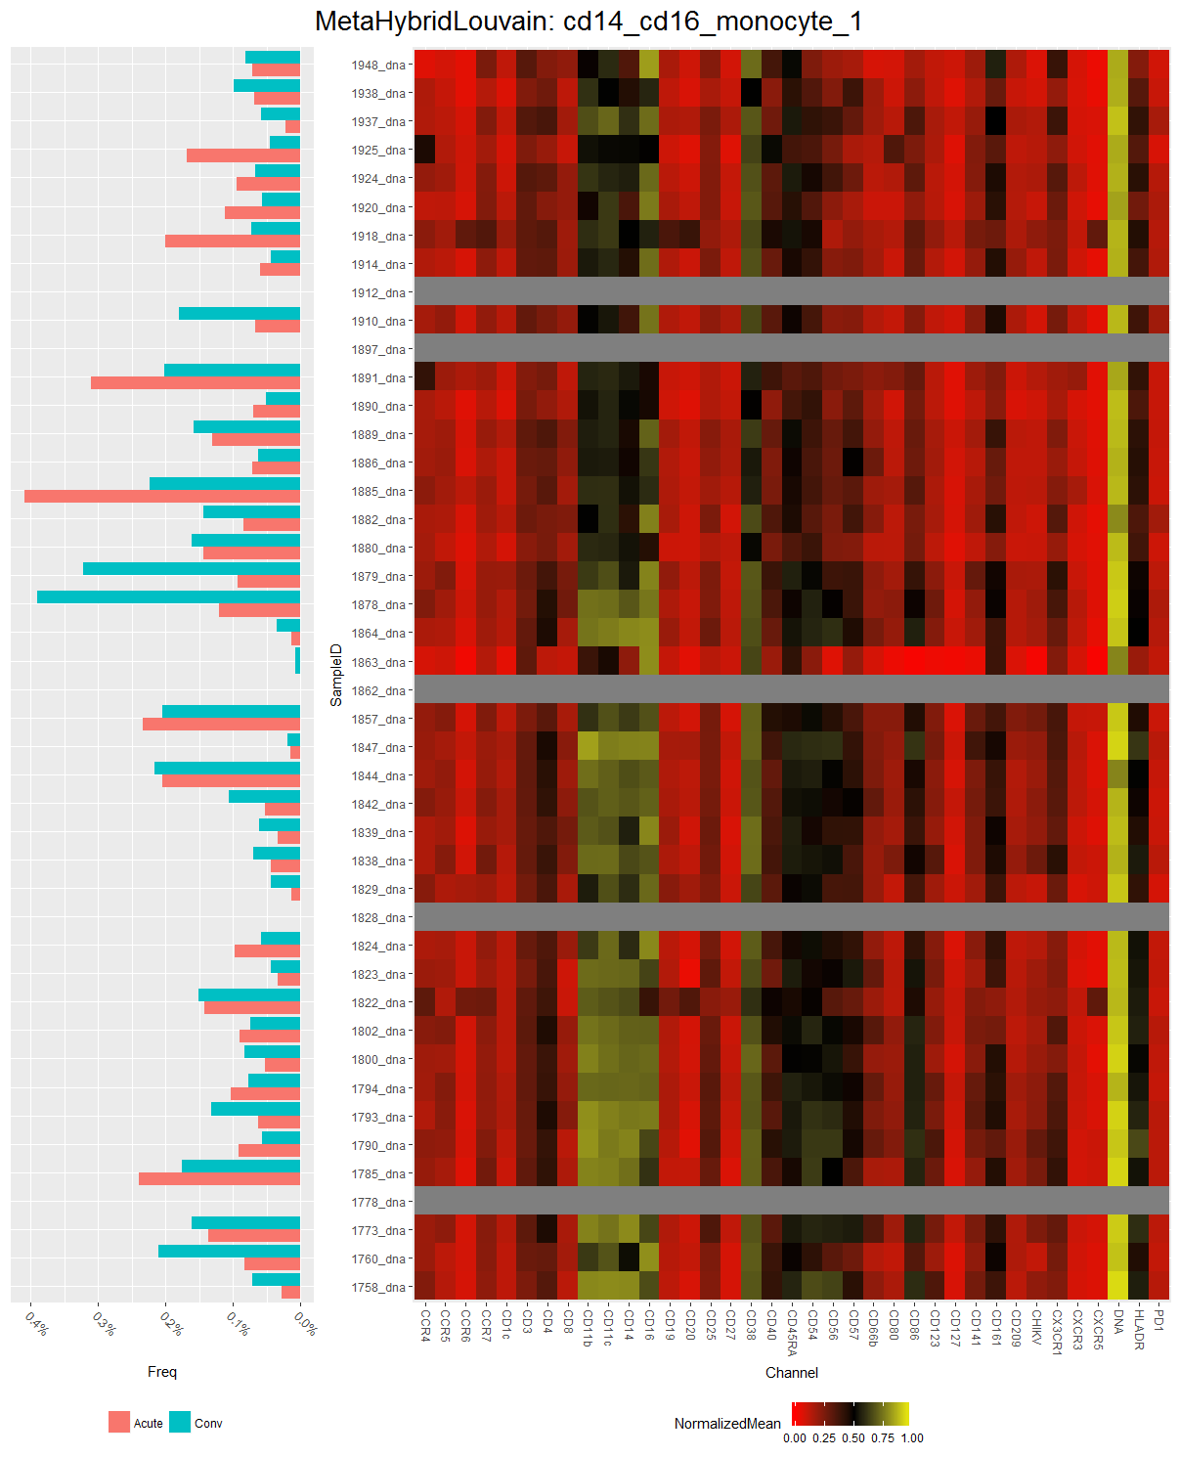

**Figure S4.** Summary of frequencies (per timepoint) and mean channel values for sub-community 1 of CD14+CD16+ monocytes, across all samples. At left, frequencies in each sample split by timepoint; at right, mini-heatmaps of channel values for all events within this sub-community for each sample (plotted within each row). A gray row indicates this sub-community was not identified in this sample.

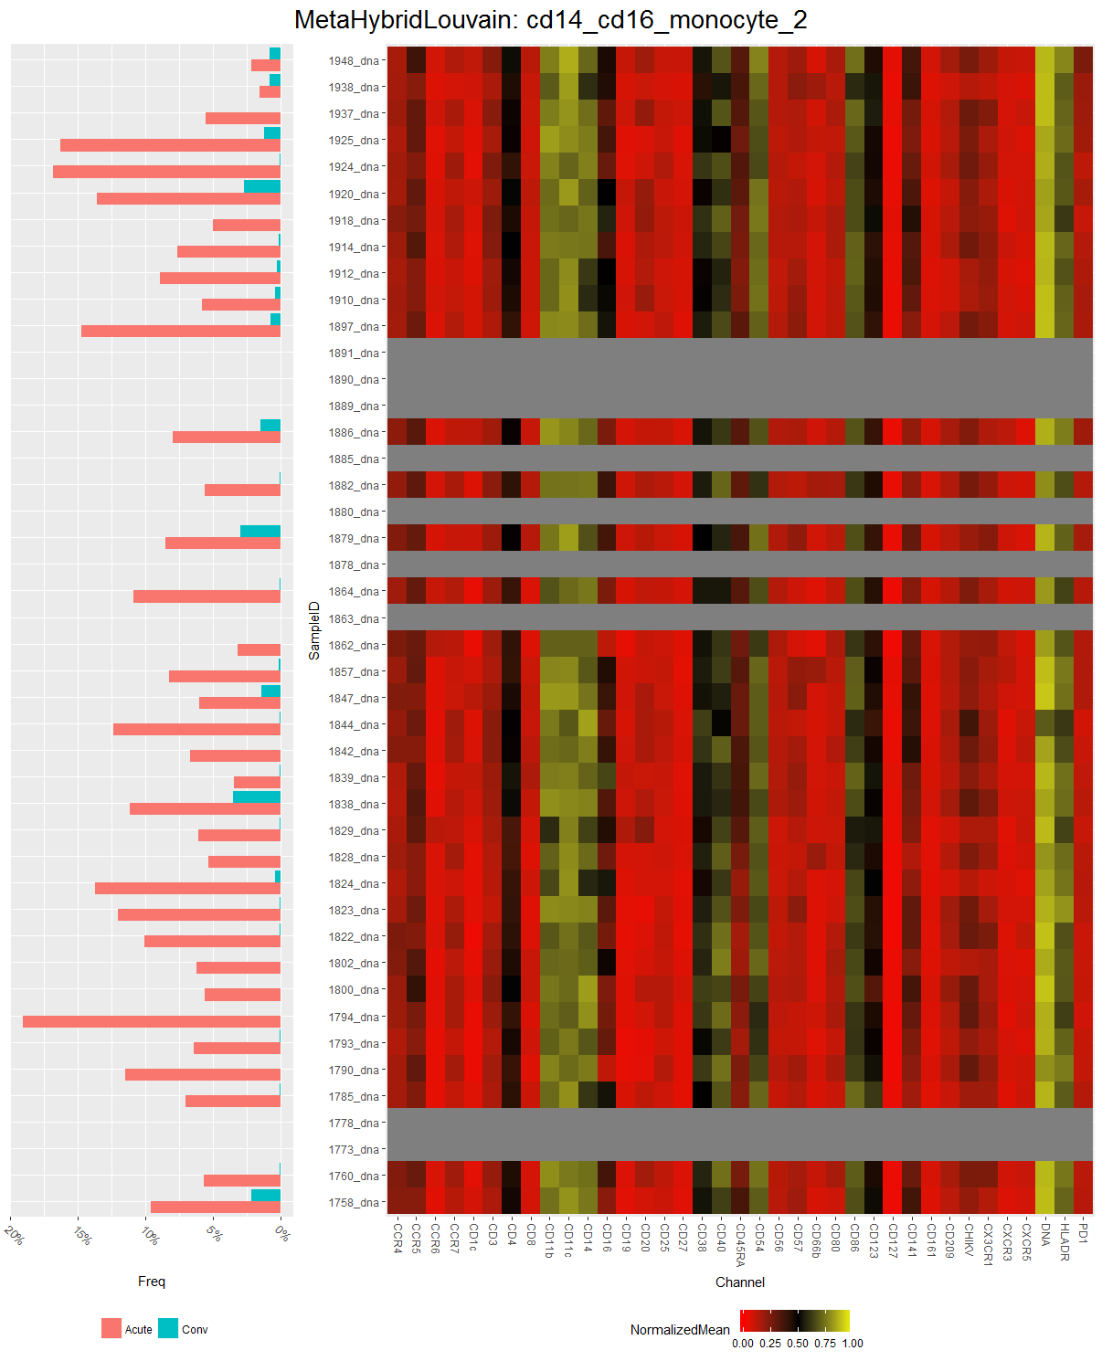

**Figure S5.** Summary of population frequencies (per timepoint) and mean channel values for sub-community 2 of CD14+CD16+ monocytes, across all samples. Layout as in Figure S4.

Macintosh HD:Users:powerpak:Dropbox:MSSM:kasarskis:dengue grant:chik paper:figs:fig_S6_cytof.MHL.subpop_channelmeans.cd14.pdf

**Figure S6.** Differences in per-sample channel means between three CD14+ sub-communities identified by MetaHybridLouvain. The X axis is filtered to only the channels with differences significant at FDR < 0.05 (Kruskal-Wallis test), and ordered from differences where sub-community 1 is greater than the other two sub-communities on the left to differences where sub-community 1 is lower than the other two sub-communities on the right.

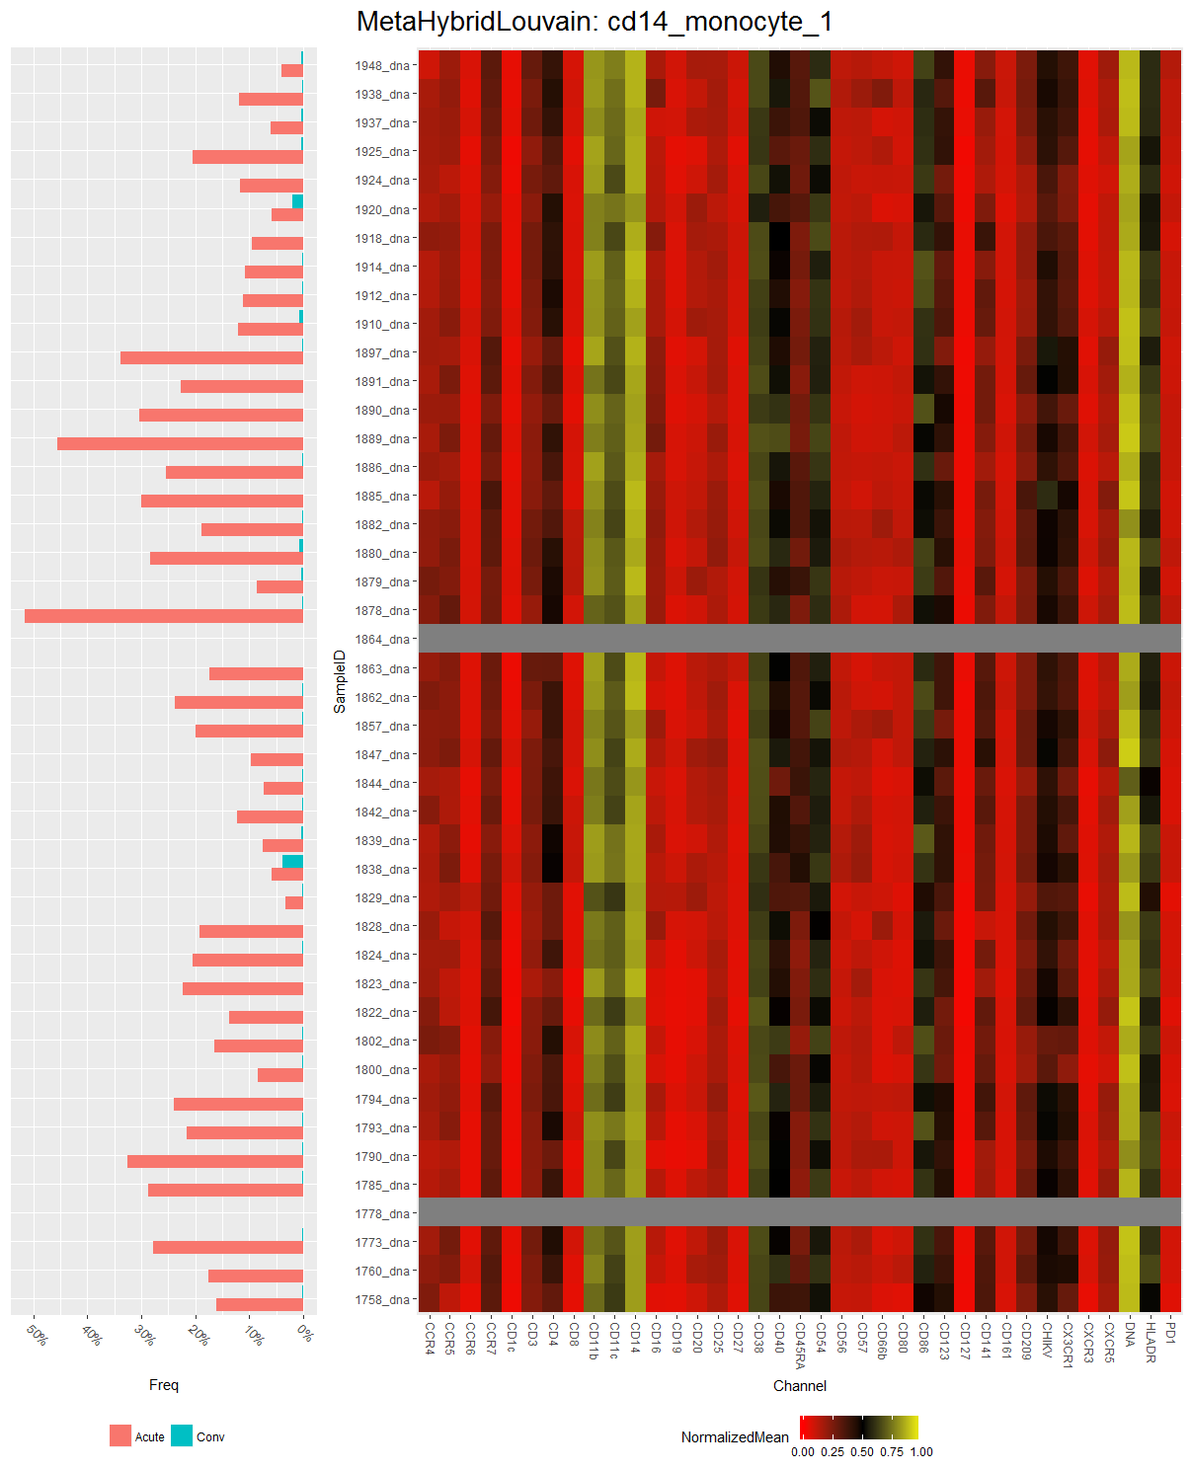

**Figure S7.** Summary of population frequencies (per timepoint) and mean channel values for sub-community 1 of CD14+ monocytes, across all samples. Layout as in Figure S4.

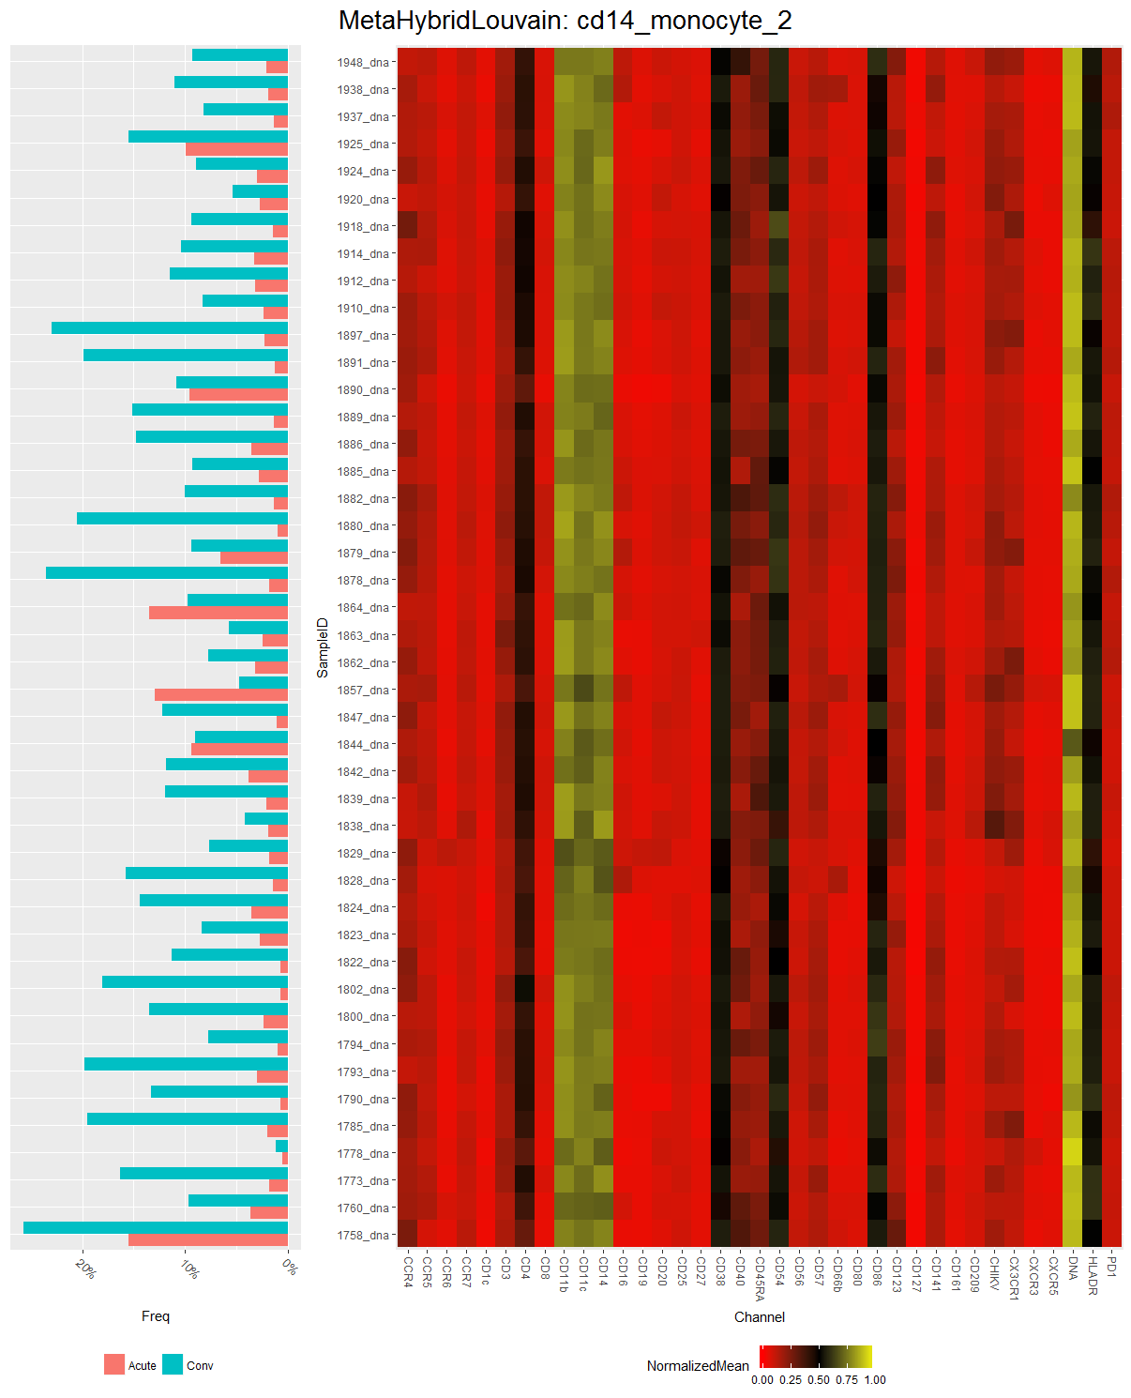

**Figure S8.** Summary of population frequencies (per timepoint) and mean channel values for sub-community 2 of CD14+ monocytes, across all samples. Layout as in Figure S4.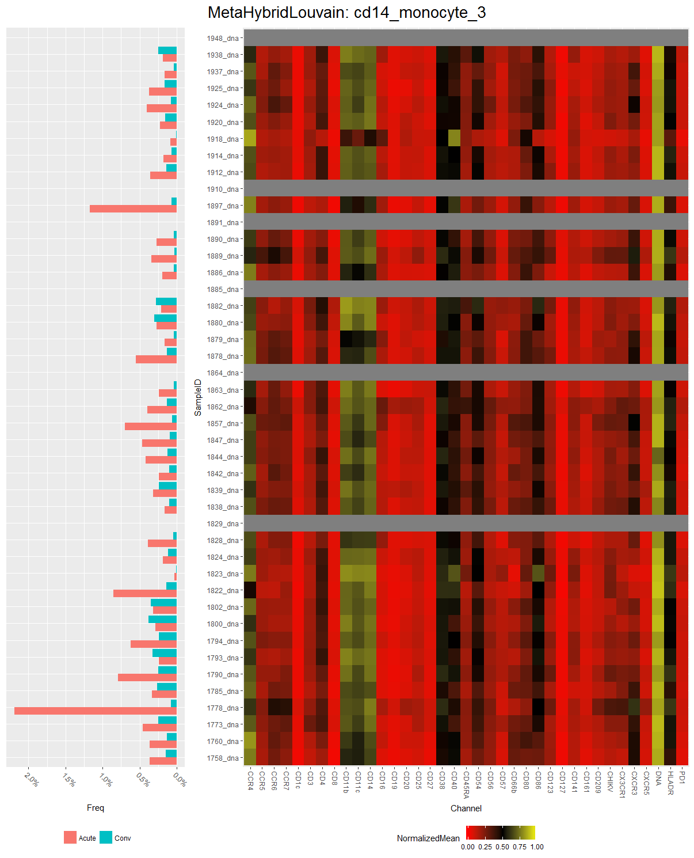

**Figure S9.** Summary of population frequencies (per timepoint) and mean channel values for subcluster 3 of CD14+ monocytes, across all samples. Layout as in Figure S4.

Macintosh HD:Users:powerpak:Dropbox:MSSM:kasarskis:dengue grant:chik paper:figs:fig_S10_nonsig_luminex.pdf

**Figure S10.** Differences in serum growth factor and colony-stimulating factor levels between the acute and convalescent timepoints, as measured by multiplex ELISA (Luminex). None of the differences depicted here achieved statistical significance at FDR < 0.05 (Wilcoxon signed-rank test).

Macintosh HD:Users:powerpak:Dropbox:MSSM:kasarskis:dengue grant:chik paper:figs:fig_S11_corrplot.luminex-cytof.all.both-times.pdf

**Figure S11.** Clustered heatmap of Pearson correlations between log-scaled serum cytokine concentration (Luminex) and log-scaled cell subphenotype frequencies (CyTOF) *across the acute and convalescent timepoints*. The source of each variable (CyTOF vs. Luminex) is depicted by the pink-green annotation bar.

Macintosh HD:Users:powerpak:Dropbox:MSSM:kasarskis:dengue grant:chik paper:figs:fig_S12_corrplot.luminex-cytof.all.acute.pdf

**Figure S12.** Clustered heatmap of Pearson correlations between log-scaled serum cytokine concentration (Luminex) and log-scaled cell subphenotype frequencies (CyTOF) *within the acute timepoint*. The source of each variable (CyTOF vs. Luminex) is depicted by the pink-green annotation bar.

Macintosh HD:Users:powerpak:Dropbox:MSSM:kasarskis:dengue grant:chik paper:figs:fig_S13_corrplot.luminex-cytof.all.conv.pdf

**Figure S13.** Clustered heatmap of Pearson correlations between log-scaled serum cytokine concentration (Luminex) and log-scaled cell subphenotype frequencies (CyTOF) *within the convalescent timepoint*. The source of each variable (CyTOF vs. Luminex) is depicted by the pink-green annotation bar.

Macintosh HD:Users:powerpak:Dropbox:MSSM:kasarskis:dengue grant:chik paper:figs:fig_S14_corrplots_cytokines_monocytes.pdf

**Figure S14.** Clustered heatmap of Pearson correlations between log-scaled serum cytokine concentration and log-scaled monocyte subphenotype frequencies. *A*, within *acute* phase samples. *B*, within *convalescent* phase samples.

Macintosh HD:Users:powerpak:Dropbox:MSSM:kasarskis:dengue grant:chik paper:figs:fig_S15_corrplot.luminex-mrna.cytokines.both.pdf

**Figure S15.** Plot of Pearson’s correlations between serum cytokine concentrations that were significantly different between acute and convalescent timepoints and expression levels (in FPKM) for corresponding genes. Both values were log scaled before calculating Pearson’s *r*.

Macintosh HD:Users:powerpak:Dropbox:MSSM:kasarskis:dengue grant:chik paper:figs:fig_S16_corrplot.luminex-mrna.cytokines.acute-minus-conv.pdf

**Figure S16.** Plot of Pearson’s correlations between serum cytokine concentrations that were significantly different between acute and convalescent timepoints and expression levels (in FPKM) for corresponding genes, normalizing all values at the acute timepoint against convalescent values. Normalized values were log scaled before calculating Pearson’s *r*.

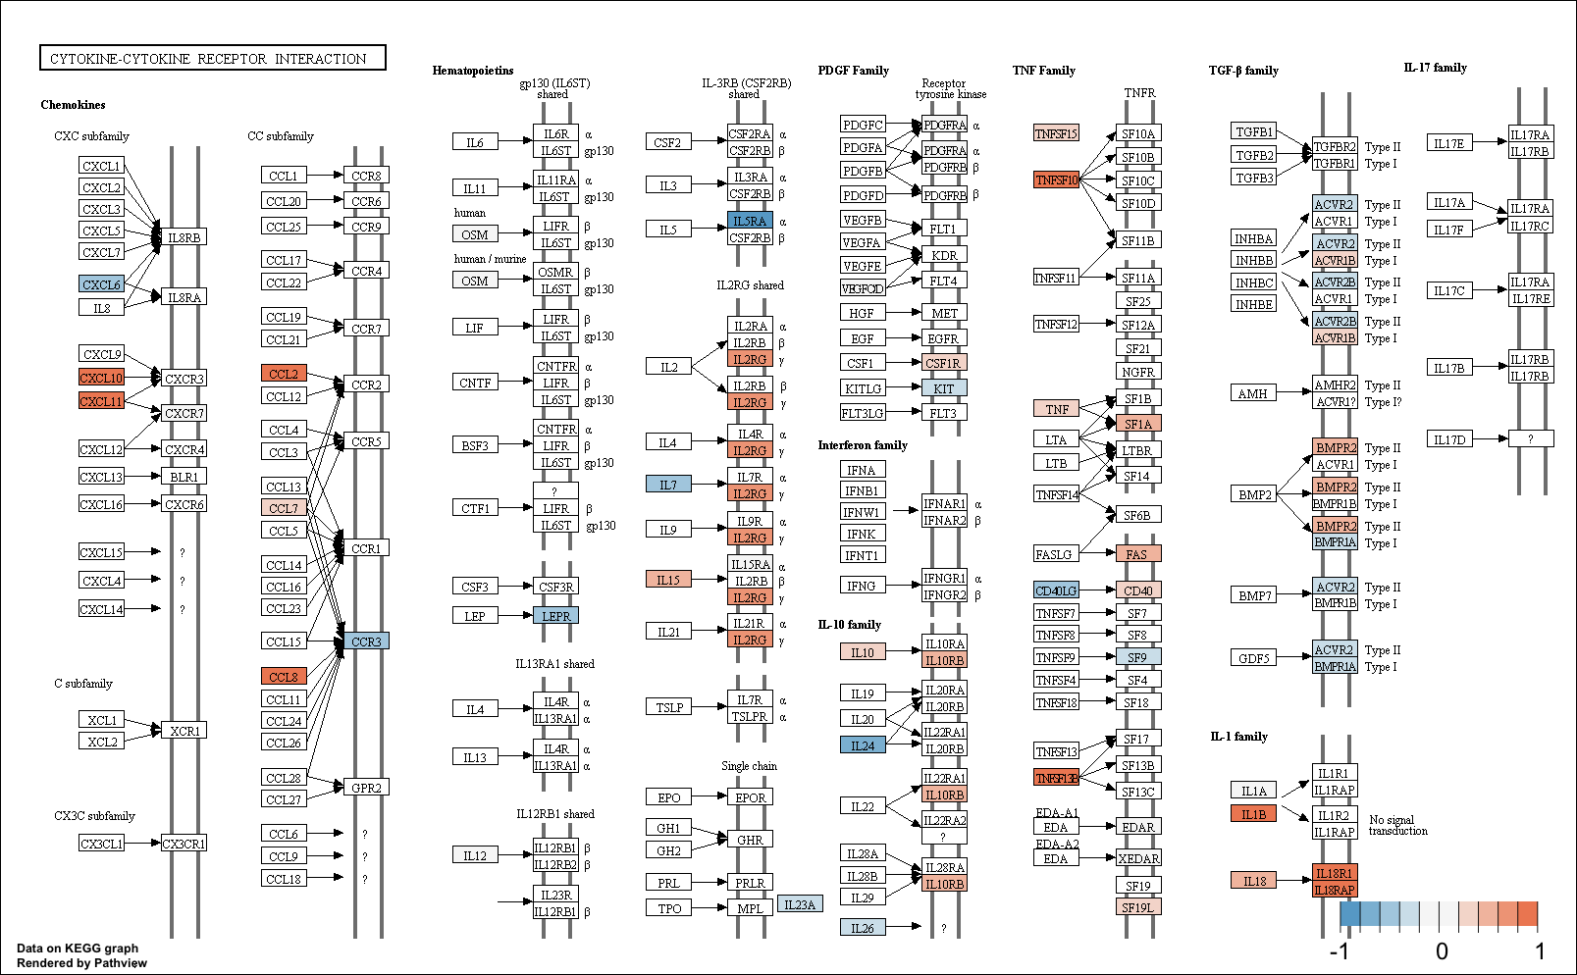

**Figure S17.** Pathview plot of log2 fold change in gene expression between acute and convalescent timepoints for the cytokine-cytokine receptor interaction pathway in KEGG (accession hsa04060). Positive values indicate upregulation during the acute phase of infection.

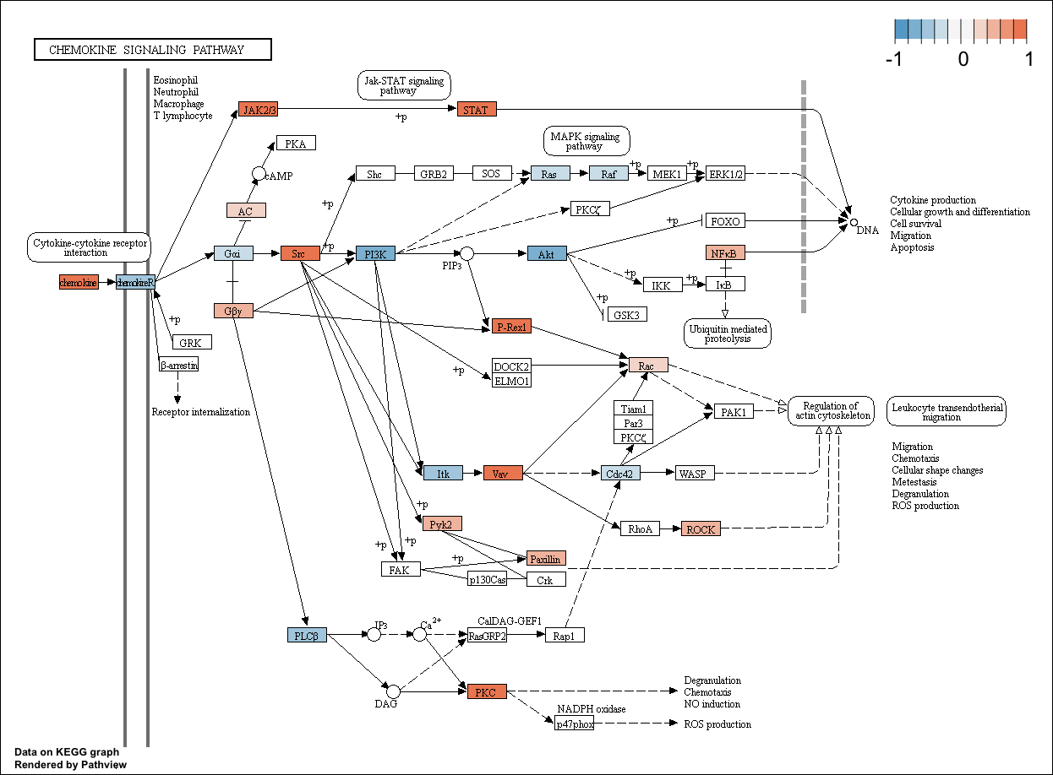

**Figure S18.** Pathview plot of log2 fold change in gene expression between acute and convalescent timepoints for the chemokine signaling pathway in KEGG (accession hsa04062). Positive values indicate upregulation during the acute phase of infection.

**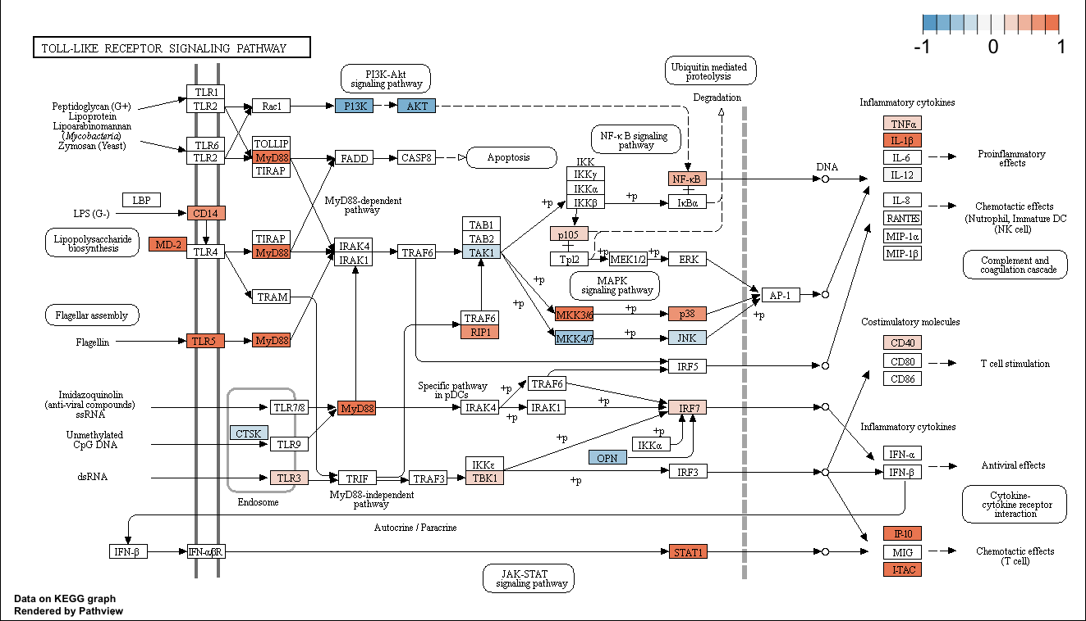**

**Figure S19.** Pathview plot of log2 fold change in gene expression between acute and convalescent timepoints for the toll-like receptor pathway in KEGG (accession hsa04620). Positive values indicate upregulation during the acute phase of infection.

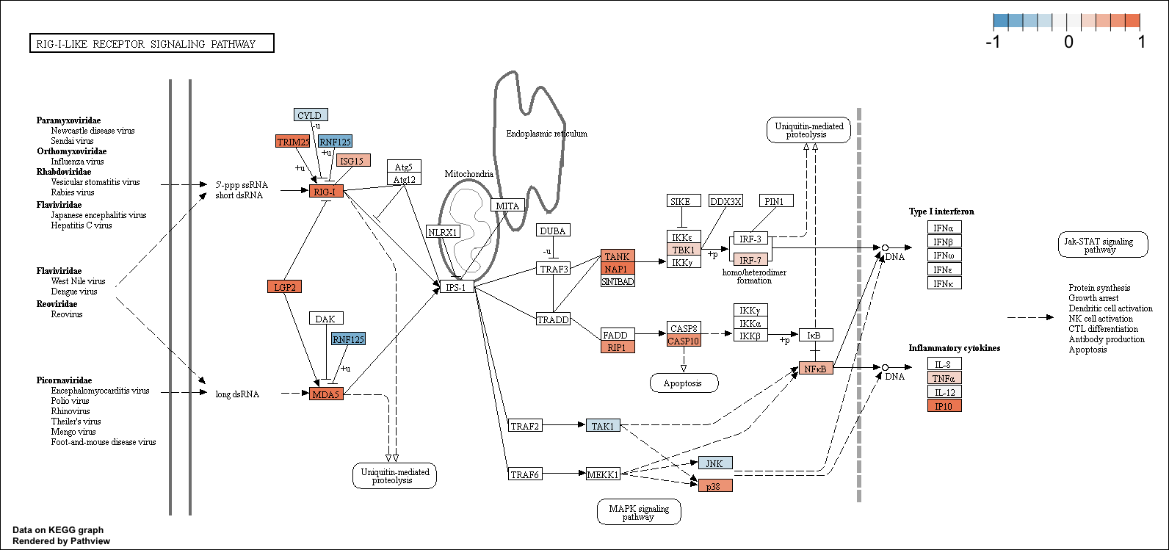

**Figure S17.** Pathview plot of log2 fold change in gene expression between acute and convalescent timepoints for the RIG-I-like receptor signaling pathway in KEGG (accession hsa04622). Positive values indicate upregulation during the acute phase of infection.

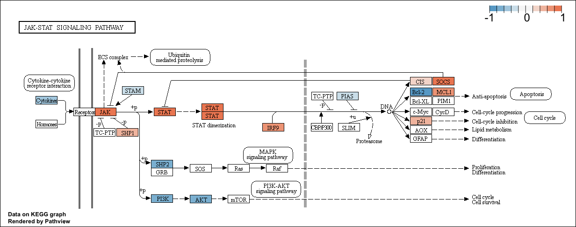

**Figure S17.** Pathview plot of log2 fold change in gene expression between acute and convalescent timepoints for the JAK-STAT signaling pathway in KEGG (accession hsa04630). Positive values indicate upregulation during the acute phase of infection.

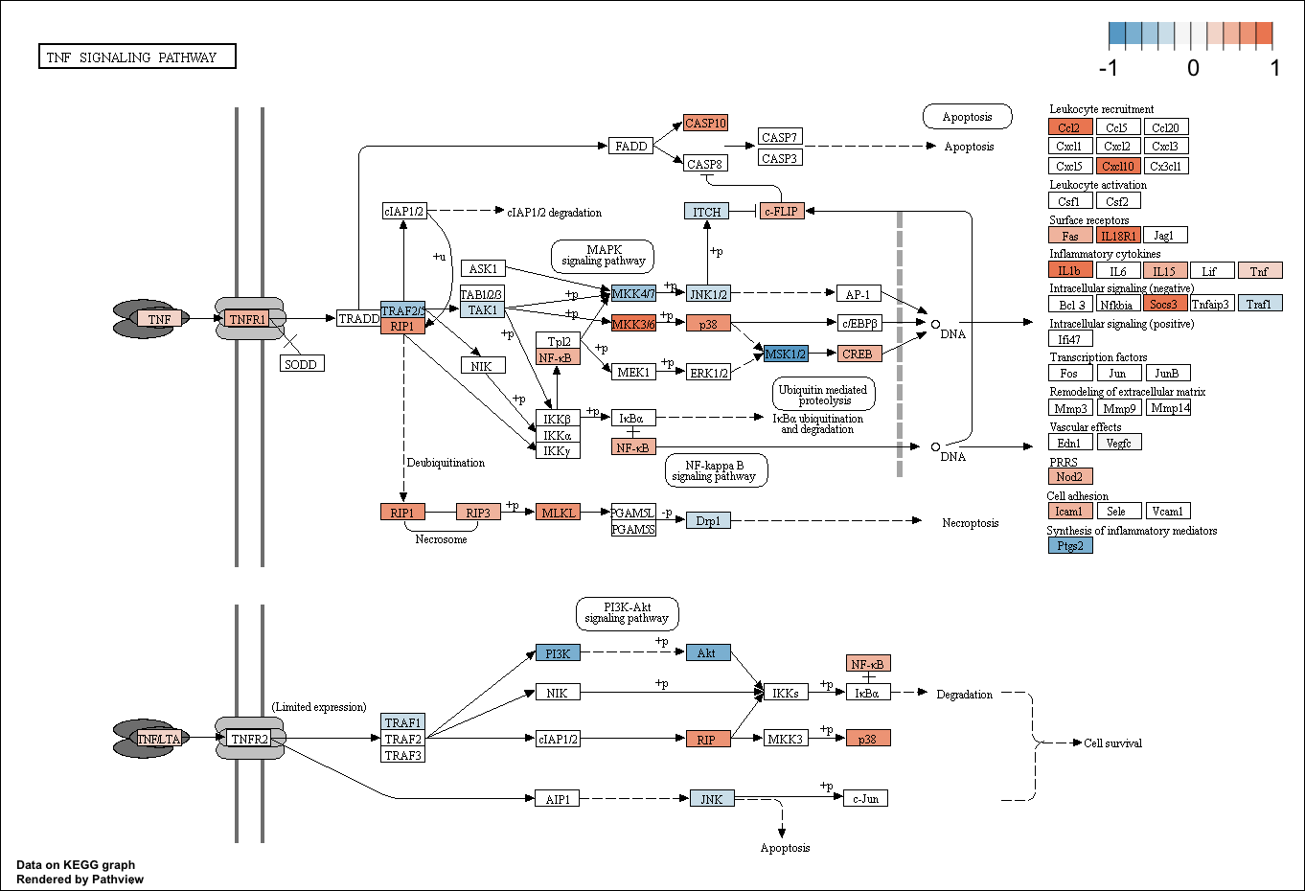

**Figure S22.** Pathview plot of log2 fold change in gene expression between acute and convalescent timepoints for the TNF signaling pathway in KEGG (accession hsa04668). Positive values indicate upregulation during the acute phase of infection.

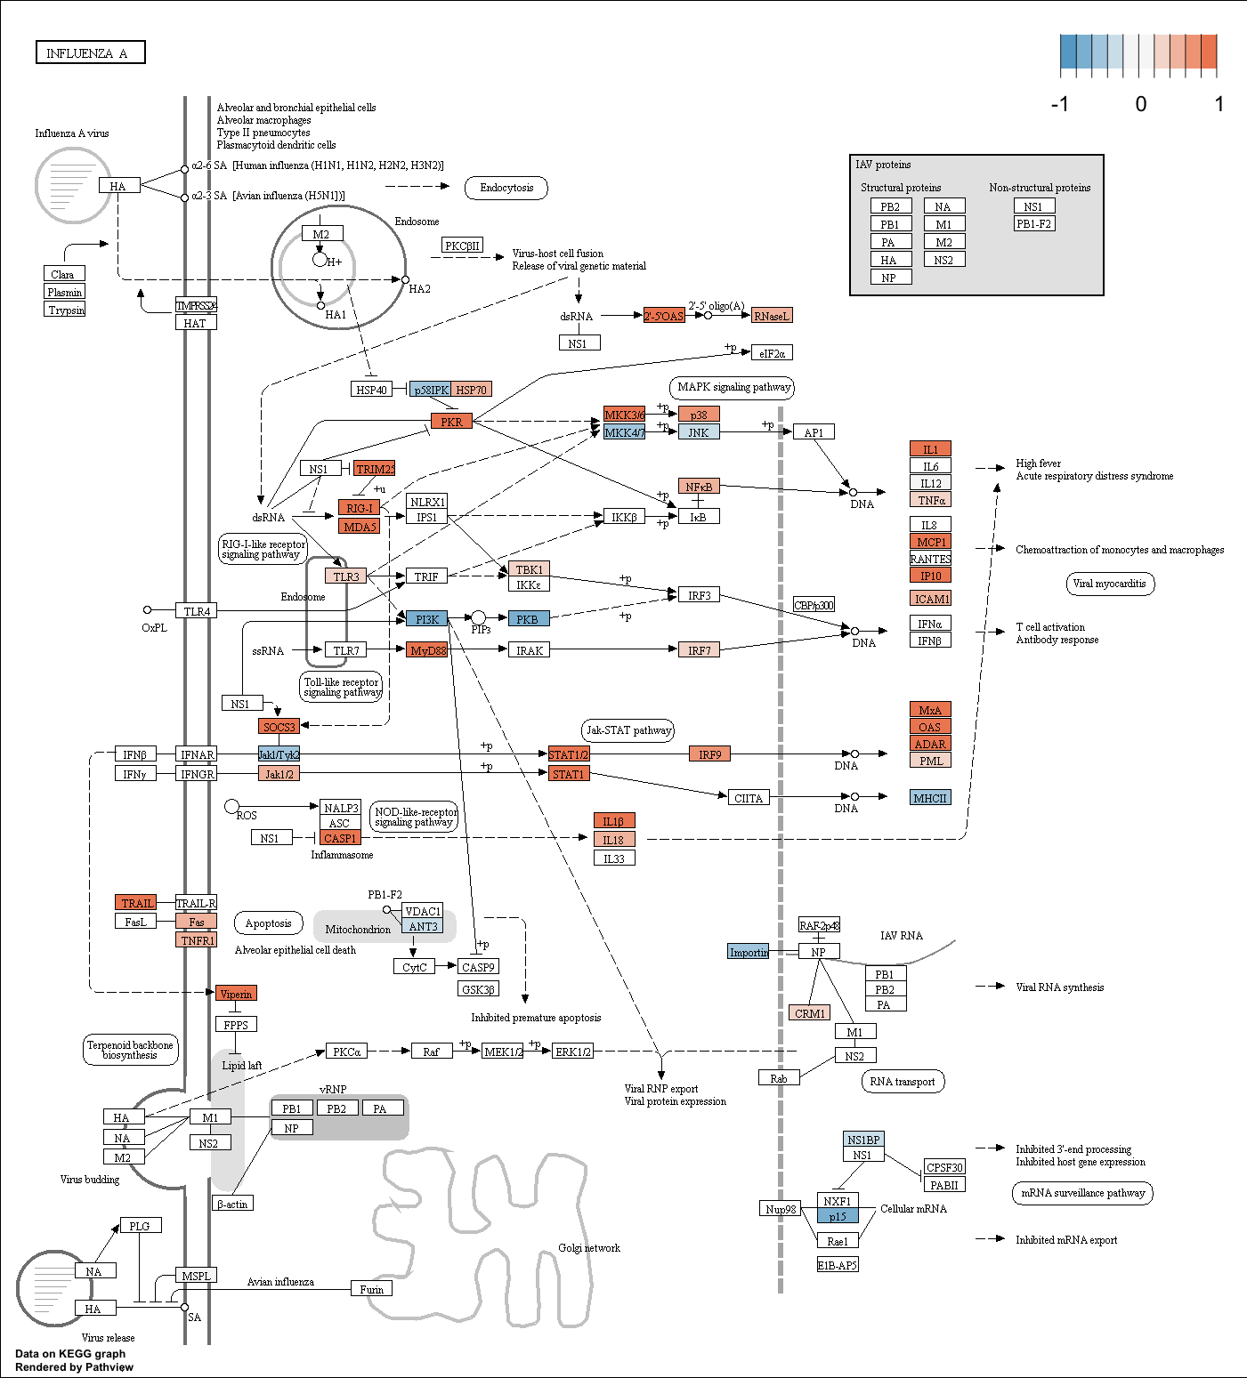

**Figure S23.** Pathview plot of log2 fold change in gene expression between acute and convalescent timepoints for the Influenza A pathway in KEGG (hsa05164). Positive values indicate upregulation during the acute phase of infection.

Macintosh HD:Users:powerpak:Dropbox:MSSM:kasarskis:dengue grant:chik paper:figs:fig_S24_sleuth.wt.severity.qq.pdf

**Figure S24.** Q-Q plot of the distribution of observed –log10 *P* values for differentially expressed transcripts between severe and non-severe cases against the distribution of –log10 *P* values expected under the null hypothesis (that no transcripts are differentially expressed.). Gray shaded band indicates the 95% confidence interval for the expected *P* value distribution under the null hypothesis.

Macintosh HD:Users:powerpak:Dropbox:MSSM:kasarskis:dengue grant:chik paper:figs:fig_S25_coexpp.net.25.modules.DET_overlaps.qvals.pdf

**Figure S25.** *q* values (Benjamini-Hochberg adjusted *P* values; Fisher’s exact test) for enrichment analyses of five differentially expressed transcript signatures among the 92 coexpression modules created with whole genome coexpression network analysis (WGCNA).

Macintosh HD:Users:powerpak:Dropbox:MSSM:kasarskis:dengue grant:chik paper:figs:fig_S26_cytof-luminex-genemodules.pdf

**Figure S26**. Weighted multiscale interaction network depicting all Pearson’s correlations between subpopulation frequencies (gold nodes), serum cytokine concentrations (small black nodes), coexpression modules (gray nodes), and clinical variables (large black nodes). Edges are filtered to correlations significant at *P* < 0.001, and thickness is scaled to the magnitude of the correlation.

Macintosh HD:Users:powerpak:Dropbox:MSSM:kasarskis:dengue grant:chik paper:figs:fig_S27_elasticnet.pdf

**Figure S27**. Receiver operator characteristic curves measuring the performance of elastic net logistic regression models predicting the phase of infection (acute vs. convalescent) for each sample, using progressively reduced versions of the dataset. Thin grey lines show the ROC curves for 100 bootstrap replicates. The area under the curve (AUC) along with its 95% confidence interval are shown underneath each plot; a perfect classifier would achieve AUC=1 while a random classifier is expected to achieve AUC=0.5 (dashed diagonal line). *A*, model trained using all CyTOF sub-community frequencies, all quantified RNA-seq transcripts, and all Luminex cytokine measurements achieves near-perfect performance. *B*, model trained as in *A* but with eigengene values for 92 coexpression modules replacing the RNA-seq transcript-level quantification; performance is slightly decreased but remains within the confidence interval for *A*’s AUC. *C*, model trained as in *B* but without Luminex cytokine measurements; performance is equivalent to the model trained in *B*.